**WebDriver Installation and Integration in Eclipse**

Development Environment

* Eclipse IDE for Java Developers Version
* Version: 2021-09 (4.21.0)
* OS: Windows 10, v.10.0, x86_64 / win32
* Java vendor: Oracle Corporation
* Java runtime version: 16.0.1+9-24
* Java version: 16.0.1

Step 1: Downloading Selenium Standalone Server jar

Search on Browser: https://www.selenium.dev/downloads/

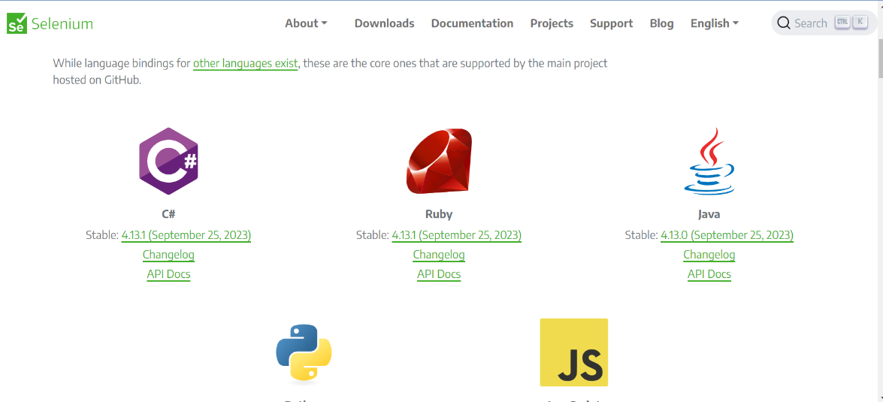

**Step 2: Click on java 4.13.0**

**Step 3: Extract downloaded jar file**

**Step 4: Create a Java project**

**Step 5:Add selenium jar file in project class path**

